***** story about
going poop in the toilet.

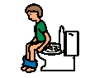

I am learning to go poop in the toilet! This is how I go poop in the toilet.


I do not poop in my pants.

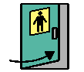

When I feel like I have to go poop. I hurry to the bathroom.

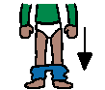

I pull down my pants.

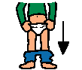
I pull down my underwear.

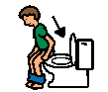
I sit down on the toilet seat.

Now I try to go poop in the toilet. I will have to sit until the timer rings.

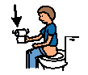
Now I get some toilet paper and wipe my bottom. Or I ask for an adult to help wipe me.



Yeah, I went poop in the toilet! I get off the toilet.

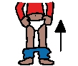
I pull up my underwear.

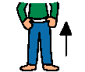
I pull up my pants.

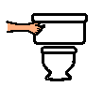
I flush the toilet one time.


I wash my hands.

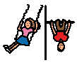
I am ready to go play again!


I am happy that I can go poop in the toilet. My parents and teachers are happy too!

